A SMALL OFFICE NETWORK

Q1. Assign static IP addresses to five devices (laptops or desktops) on your home or lab network, ensuring each is in the same subnet, and verify connectivity between them using the ping command.
Ans. Here I have created a small local network and gave them static IP and they all are communicating with each other
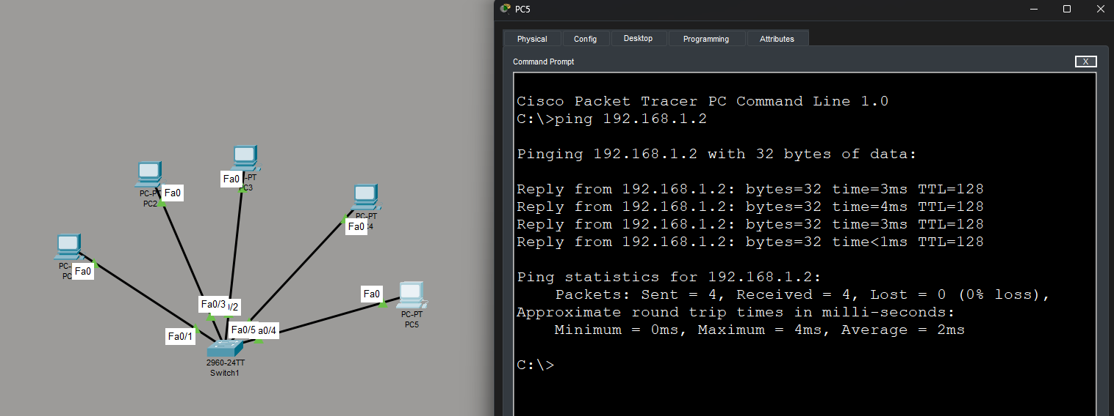

Q2. Set up a DHCP server (using your router or software like Packet Tracer/GNS3/VirtualBox) to automatically assign IP addresses to at least three devices, and confirm that each device receives a unique IP from the correct range.
Ans. Here I have configured DHCP services through Router and each pc is getting IP from the DHCP services and communicating well with each other
- I have use IP DHCP pool command in router with the stating range of IP – 192.168.10.2
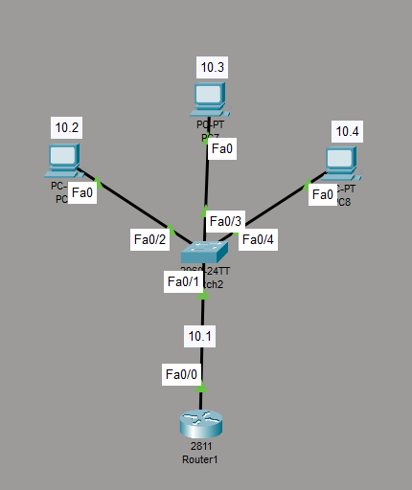

Q3. Configure a DNS service (using your router’s DNS settings or a tool like dnsmasq) so that typing a custom hostname (e.g., musicplayer.local) in a browser on any connected device opens a specific local web page or device interface. Hint: You can map hostnames to local IPs using the DNS service or by editing the hosts file for a quick test.
Ans. Configure Custom DNS Hostname – musicplayer.local
- For a simple lab setup, the Windows hosts file can be used to map the hostname to a local web server.
Step 1: Set up a local web server
Assume the local web server/device has this IP: 192.168.10.50
Make sure a webpage is running at that address.
Step 2: Edit the hosts file
Open Notepad as Administrator and open:
C:\Windows\System32\drivers\etc\hosts
Add: 192.168.10.50 musicplayer.local
Save the file.
Step 3: Clear the DNS cache
Open Command Prompt: ipconfig /flushdns
Step 4: Test hostname resolution
Run: nslookup musicplayer.local
Or: ping musicplayer.local
It should resolve to: 192.168.10.50
Step 5: Open the local webpage
Open a browser and enter: http://musicplayer.local
The webpage hosted at 192.168.10.50 should open.
Conclusion: The custom hostname musicplayer.local was mapped to the local IP address 192.168.10.50, allowing the local webpage to be accessed by name instead of entering the IP address.

Q4. Create two VLANs (e.g., VLAN 10: 'Workstations', VLAN 20: 'Smart Devices') on your switch or simulation tool, assign at least two devices to each VLAN, and demonstrate that devices in the same VLAN can communicate, but not with devices in the other VLAN. Hint: Use ping or file sharing to test connectivity between devices in different VLANs.
Ans. Here I have created 2 VLAN on a switch by VLAN 10 for HR and VLAN 20 for Admin and I have used a server to allot IP to the devices. I have used Fast Ethernet port 0/2-4 for VLAN 10 and Fast Ethernet port 0/5-6 for VLAN 20 and the devices which are connected to the VLAN 10 with server gets the IP through Server Waya DHCP services but the devices which are connected to clan 20 didn’t get IP from server Waya DHCP services even they are on same subnet or same class
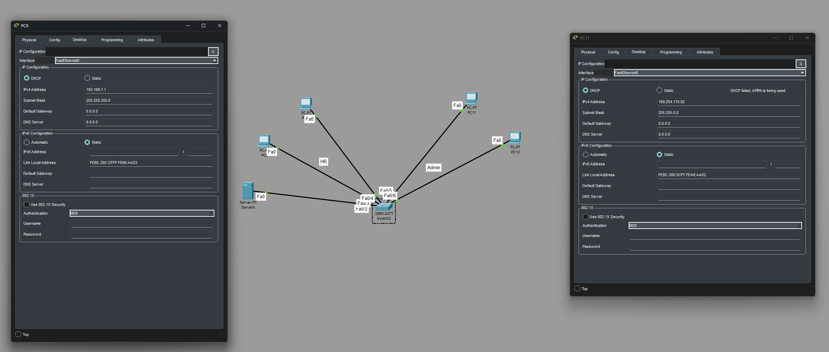

Q5. Simulate internet access for your LAN by configuring a router with NAT (Network Address Translation), then test that devices on your LAN can access an external site (e.g., www.wikipedia.org) or a simulated external server.
Ans.
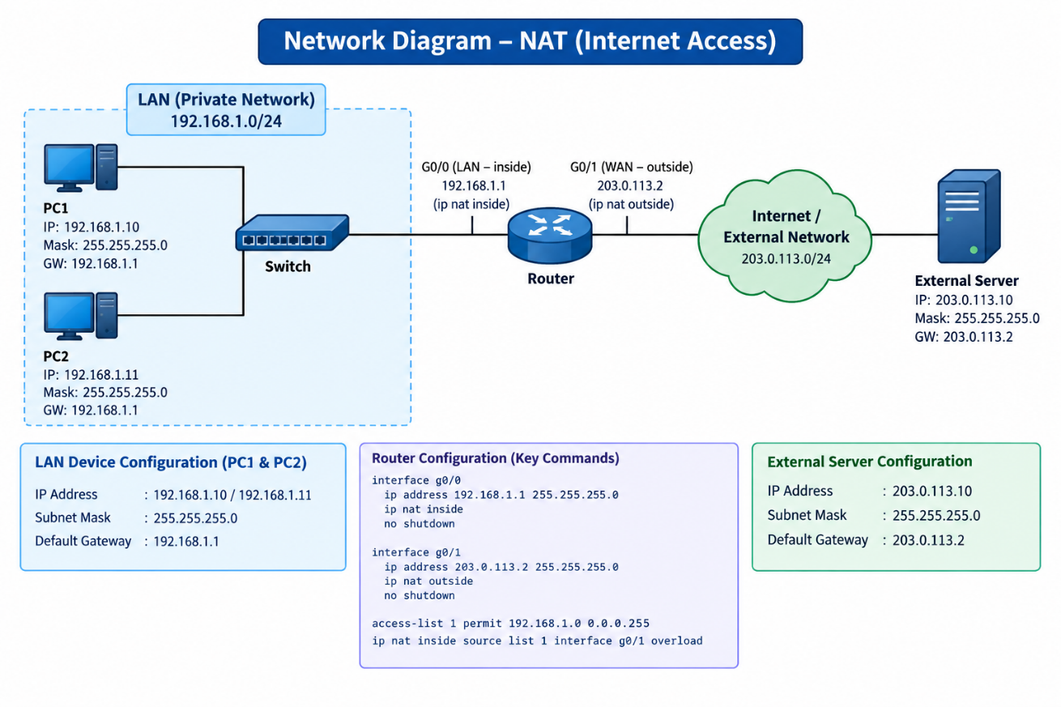
Simulating Internet Access Using NAT
Objective: - The objective of this setup is to simulate Internet access for devices on a LAN by configuring a router with NAT (Network Address Translation).

Network Setup
- The network consists of two PCs connected to a switch. The switch is connected to a router, which provides access to an external network/server.
- PC1: 192.168.1.10
- PC2: 192.168.1.11
- Router LAN interface (G0/0): 192.168.1.1
- Router WAN interface (G0/1): 203.0.113.2
- External Server: 203.0.113.10
- Subnet Mask: 255.255.255.0
NAT Configuration
- The router's G0/0 interface is configured as the NAT inside interface, while G0/1 is configured as the NAT outside interface.
- An access list permits the LAN network 192.168.1.0/24, and NAT overload translates the private IP addresses of the PCs to the router's outside IP address.
Testing
From PC1 or PC2, the external server can be tested using: ping 203.0.113.10
The NAT translations can be checked on the router using: show IP Nat translations
Result: - The test confirms that LAN devices using private IP addresses can communicate with the external server through the router. NAT successfully translates the private LAN addresses into the router's outside address, simulating Internet access.

